**Check for character**

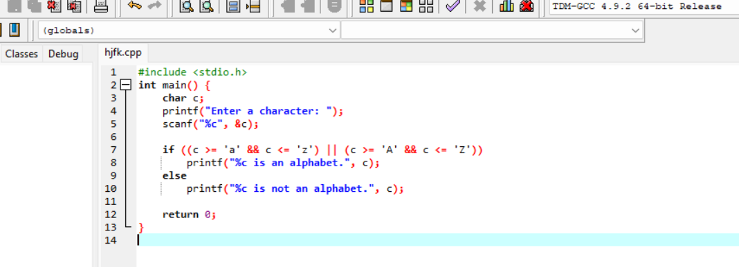

**Output**

